**EXPLAINING THE STARS: ASPECT-BASED SENTIMENT**

**ANALYSIS OF ONLINE CUSTOMER REVIEWS**

**1 Introduction**

However, these models mostly rely on latent variables which are hard to interpret as they do not necessarily represent the thematic aspects focussed by the users when reviewing the item. Indeed, explaining and interpreting the overall star ratings based on such predictive models is not aimed at or possible.

Aspect-based sentiment analysis accounts for the review texts including the users’ assessments of different aspects of the rated items in a methodically well-founded way. In that line, we use aspect-based sentiments contained in the review texts and propose an approach to explain and interpret the users’ overall star ratings. We focus on the following research question:

*How can aspect-based sentiments contained in the textual parts of online customer reviews be*

*used to explain and interpret the associated overall star ratings?*

**2 Related Work and Research Gap**

However, existing literature lacks an explanatory model using aspect based sentiments to explain the associated overall star ratings which addresses the occurring methodical issues (e.g., ordinal scale of the star ratings). Furthermore, the explanatory power of (different sets of) aspect-based sentiments has not been investigated yet. Due to the methodical issues arising, amongst others from the ordinal scale of the star ratings, this is particularly challenging.

**3 A Model to Explain Star Ratings**

To address this research gap, we propose an explanatory model for overall star ratings with respect to aspect-based sentiments, which addresses the methodical issues associated with the star ratings.

**3.1 Basic idea of our approach**

Our aim is to explain the overall star ratings of textual reviews based on the associated aspect-based sentiments.

To adequately represent star ratings, we follow a two-step approach. First, an underlying model for continuous preferences instead of discrete star ratings is established. Then, a non-linear transformation of the underlying preferences onto the rating scale is used. More precisely, the ratings are modelled by dividing the underlying continuous preference variable into intervals of different size.

**3.2 Generalized ordered probit model to analyse aspect-based sentiments**

We consider a set of M ∈ N textual reviews. Each review is associated with a star rating 􀝎 on a discrete scale from 1 to a maximal rating of K ∈ N.

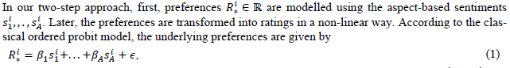

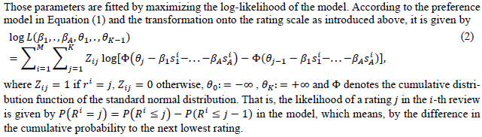

**3.3 Measure to assess the explanatory power for the proposed model**





**4 Evaluation**

**4.1 Case selection and preparation of the dataset**

First, aspect-based sentiments have to be extracted from the reviews in the dataset. For our

evaluation, we applied separate sentiment dictionaries for different aspects in the restaurant context. This allowed us to account for varying sentiment orientations depending on the referred aspect.

**4.2 Methodical evaluation of our approach**

**4.3 Results for selected aspect-based sentiments**

**5 Implications for Theory and Practice**

In contrast to existing approaches for explaining the star ratings of online customer reviews, our approach takes advantage of the valuable information contained in aspect-based sentiments which are measured in the review texts. Furthermore, it addresses the methodical issues which emerge during the explanation of overall star ratings, particularly due to their ordinal scale. Using our approach, marketing analysts can study the reasons for customer (dis)satisfaction on a detailed level. This allows them to ensure customer orientation by considering client needs and meeting their major priorities.

**6 Conclusion, Limitations and Future Work**

In this paper, we present an approach to explain and interpret the overall star ratings of online customer reviews using aspect-based sentiments contained in review stexts.